Computer System Administration 2 – Python Weekly Report 1
Date: Sunday 29th January 2017
What I did:
In this week I wrote an echo client to connect to an echo server on the local machine. The echo server is set up to listen on ‘127.0.0.1’ and bind to port ‘7’and the client will try to connect to the server which is all done using the socket library, once the connection is established the user can send any arbitrary message and the server will reply with the same message which the client will print.

Specification Table
Inputs | Processing | Outputs
message | Input message  Decode message  Encode message  Send encoded message to server | Receive reply from the server

Output
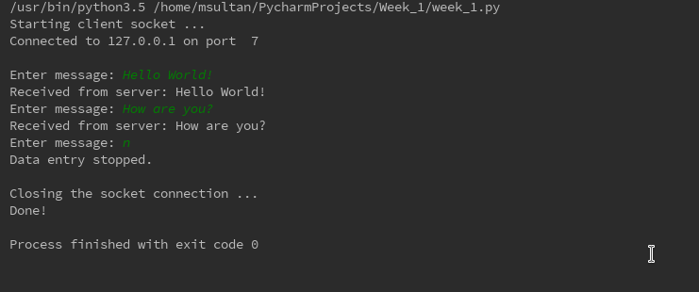
(The program will be uploaded separately)

What I learned
I learned how to use sockets in python to create a client/server and the difference between stream sockets (TCP) and datagram sockets (UDP).

Problems I have encountered
My only problem this week was setting up the echo server, as I am running Fedora Linux on my machine instead of Ubuntu Linux, the instructions for setting up the echo server didn’t apply to me but once I figured out how to set up the server on Fedora it was smooth sailing from there.

